Open Prompt “Speed Dating”

You will have a set amount of time to “get acquainted” with each prompt. Examine its meaning, look into its deeper layers, and decide how to “make conversation” with it for a pre-write. You don’t have to actually write the essay, just explore the concepts, brainstorming/questioning, and listing main points and concrete examples you had to write it. At the end of the set number of minutes, I will call time and you will pass the prompt on to the next student and receive a new one in turn. After 30 minutes, we will stop and assess your responses.

BASIC RULES:
For the 1st prompt (10 minutes)
- Read and ANNOTATE your prompt. Determine the TASK that is being asked of you. Identify SOAPS if applicable. *It is your job to take notes on the prompt and develop a deep understanding in order to guide the rest of your group in this activity! Don’t rush this part!
- State your position (defend, challenge, qualify) on the concept in the prompt.
- Write a THESIS STATEMENT for the prompt.

For the 2nd & 3rd prompts: (5 minutes each)
- Read the prompt and the thesis statement you are given.
- Add at least one piece of EVIDENCE in support of the thesis that has been written for you.
Remember, evidence can be any of the following and must be specific:
    - Reading: If you can think of a character that stands for an idea and can name the character and the novel, then use the character to prove the “guiding” quotation. (Ex: Atticus Finch and the concept of justice)
    - Observation:
      - Historical: This is an example from history. (Ex: The American Depression and the idea of lost hope)
      - Cultural: An observation can also be something you recognize in modern culture that stands for an idea. (Ex: Advertising during the Super Bowl and the idea of American gross consumption)
    - Experience: Yes, you can use evidence from your own personal experiences, but it MUST stand for an idea (like a close friend moving away and the idea of loneliness – a common experience shared by many), and you MUST be specific when relating the experience.

For the 4th prompt: (5 minutes)
- Read the prompt, thesis, and evidence that have already been written.
- Now, write a COUNTERARGUMENT/CONCESSION statement. State the opposing viewpoint and acknowledge one or more of its arguments; BUT, draw the attention back to your position with an “although” or “however” statement.

(Ex: Some might argue that not allowing minors the freedom to create personal webpages goes against the constitutional rights to free-speech; however, those rights are guaranteed for individuals over the age of 18 – at which point, he/she should have developed and learned how to effectively take responsibility for their actions and reputation.)
For your original prompt: (5 minutes)
- Read and familiarize yourself with the evidence and counterargument/concession that has been written by your teammates in response to the thesis you wrote at the beginning.
- Then, write a strong CONCLUSION (3 sentences or so) that summarizes everything and relates it to the real world.

NEXT STEPS... You will now join together with the people in your horizontal row (you should have all started/finished with the same prompt) to discuss, combine notes, and write a rough draft of an AP argument essay in response to your prompt. Turn in the completed essay before you leave class today! We will be reading, discussing, and scoring these in the next class! Good Luck!

Prompt 1:
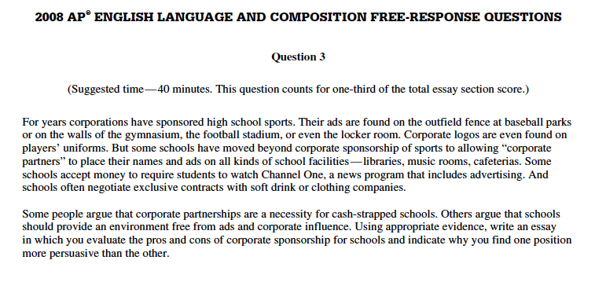

Position: _______________________________________________________________________________

Thesis: ______________________________________________________________________________________________________________________________________________________________________________________________________________________________________________________________________________

Evidence 1:

Evidence 2:

Evidence 3:

Counter-Argument:

Conclusion:

Prompt #2:
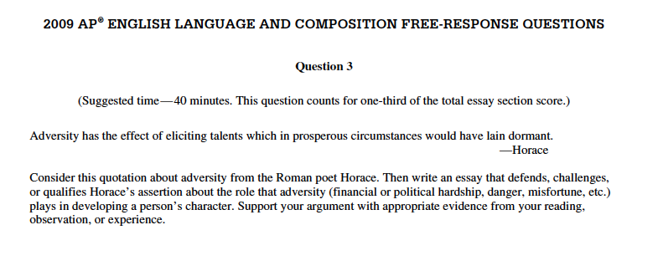

Position: _______________________________________________________________________________

Thesis: ______________________________________________________________________________________________________________________________________________________________________________________________________________________________________________________________________________

Evidence 1:

Evidence 2:

Evidence 3:

Counter-Argument:

Conclusion:

Prompt #3:
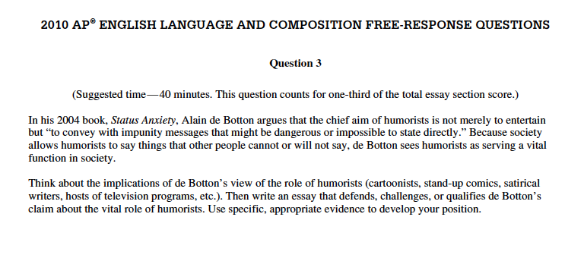
Position: _______________________________________________________________________________

Thesis: ______________________________________________________________________________________________________________________________________________________________________________________________________________________________________________________________________________

Evidence 1:

Evidence 2:

Evidence 3:

Counter-Argument:

Conclusion:

Prompt #4:
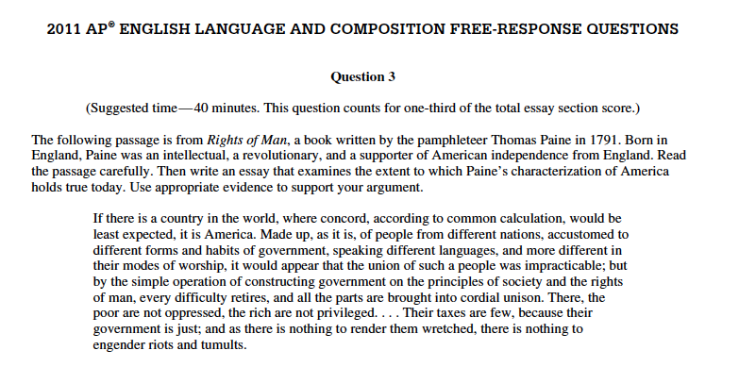Position: _______________________________________________________________________________

Thesis: ______________________________________________________________________________________________________________________________________________________________________________________________________________________________________________________________________________

Evidence 1:

Evidence 2:

Evidence 3:

Counter-Argument:

Conclusion:

Prompt #5:
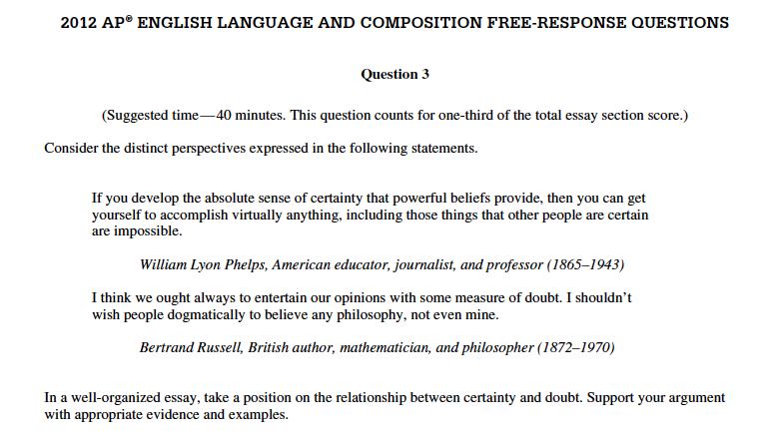

Position: _______________________________________________________________________________

Thesis: ______________________________________________________________________________________________________________________________________________________________________________________________________________________________________________________________________________

Evidence 1:

Evidence 2:

Evidence 3:

Counter-Argument:

Conclusion:

Which prompt do you think would be the easiest to write an essay on? ________

Which prompt do you think would be the hardest to write an essay on? _______

