SAT 100 Vocabulary Study Cards

In addition to preparing you for the SAT, research shows that vocabulary is closely linked to academic success. A strong vocabulary is essential to good reading and, because reading and writing are so closely related, essential to good writing (Brynildssen, 2000, 1). Research also demonstrates that vocabulary study is most effective when students construct their own meaning and are able to visually represent a word and its related term (Smith, 1997, 1-2). By closely looking at an individual word, students will be able to learn, in addition to its definition, a lot about the way that language works. To do this, we are going to use a study method called “Vocabulary Cards.”

For each vocabulary term, you should produce one study card with the following information in the format shown:

- Divide the word into prefix, suffix, and root – not syllables. (Note: Not all words have prefixes and suffixes, but some have more than one prefix and/or suffix.)

- Find and list the meaning of each part of the word. (Refer to the chart you have been given.)

- Find and list three words with the same root. (This can usually be done by looking at words on the same dictionary page as the word, but you are encouraged to look around!) *If you cannot find these, just list SYNONYMS.

- Do a quick draw of the concept of the word, not the definition. (For example: A picture of the definition of the word pedestrian would be a person walking. A picture of the concept could be a foot.

- At the bottom of the card, write the definition as it has been given to you.

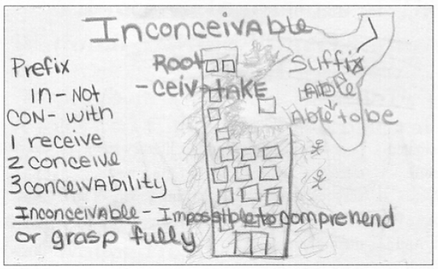

- On the opposite side of the card, write the part of speech and at least TWO sentences using your word. Be creative here and make sure you are writing sentences that give us a clue to the word’s meaning. (We will use this side of the cards to practice for the fill-in-the-blank style questions you will see on your quizzes and the SAT itself.)

- Quizzes will be approximately every two weeks (1 or 2 a month)

- Each quiz will be worth 30 points and will test on FIFTEEN words in SAT-style (fill-in-the-blank) form.

- 10 questions will be on “new words,” and 5 questions will be on vocabulary terms from previous lists. *Students are encouraged to go back and review their ALL their study cards frequently and regularly.

*Concept and sample image taken from “Visualizing Vocabulary” by Eileen Simmons.

