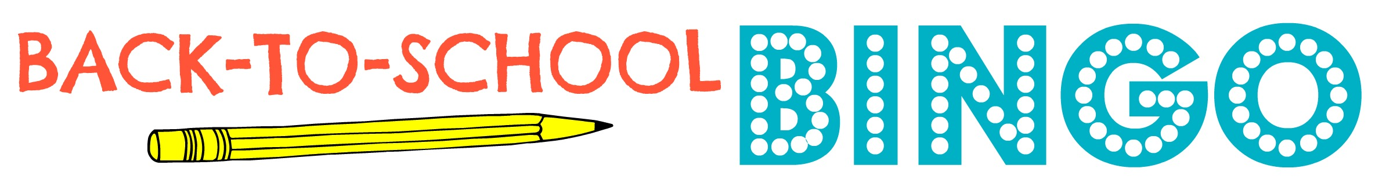

 | Textbook | Respect | Hilarious | Fun
Novel | Grammar | Test | Binder | Blackboard
Synergy | Pencils | 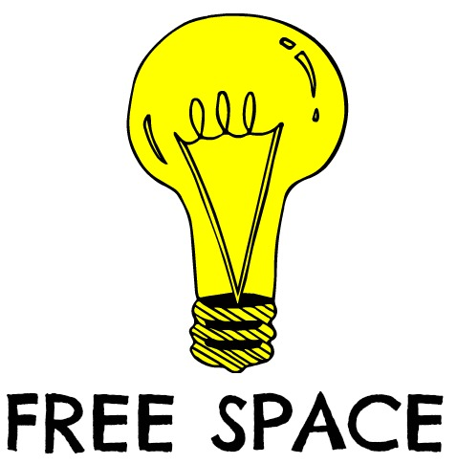 | Journal | Writing
Reading | Responsibility | Homework | Laptop | Highlighters
Journal | Group Work | Numbers | Yellow Sheet

Novel | Laptop | Journal | Blackboard | Hilarious
Pencils |  | Synergy |  | Homework
Writing | Respect |  |  | Reading
Yellow Sheet | Highlighters | Group Work | Forms | Clipboard
Food/Drink |  | Planner | Organized | Textbook

Blackboard | Organization | Yellow Sheet | Respect | Base School
BCAT | Break | Materials | Synergy | Forms
 | Novel |  | Homework
Composition Notebook | Laptop |  | Pens | Binder
 | Planner | Pencil | Highlighters

Group Work | Synergy | Grammar | Writing | Literature
Respect | Yellow Sheet | Laptop |  | Hilarious
Attendance | Forms |  | Materials
Planner | Food/Drink |  |  | Pencils
SOLs | College | Prepared | Work Hard | Fun

Textbook | Laptop | Journal | Blackboard | SOLs
AP |  | Synergy | Materials | Homework
Learn | Respect
Yellow Sheet | Composition Notebook | Group Work |  | Grammar
Group Work |  | Work Hard | Organized | Online

Textbook | Laptop | Journal | Blackboard | Hilarious
Pencils |  | Synergy |  | Homework
Forms | Respect |  |  | Reading
Yellow Sheet | Highlighters | Group Work |  | Clipboard
Food/Drink |  | Fun | Organized | Online

Synergy |  | Group Work | Blackboard | College Credit
AP |  | Synergy | Materials
SOLs | Respect
Yellow Sheet | Highlighters | Announcements | Journal | Grammar
Hilarious |  | Work Hard | Organized | Fun

 |  | Fun | Blackboard | Yellow Sheet
Respect |  | Synergy | Materials | Homework
Family | AP |  | Novels | Pencils
Yellow Sheet | Composition Notebook | Group Work |  | Grammar
Hilarious | Policy | Markers

Composition Notebook |  | Grammar | Blackboard | Online
 | Homework | Attention | Respect | Textbook
Paperwork | Food |  | Responsibility
Assignments | Synergy | Break | SOLs | Signature
 | Hilarious | Novel | Family | Fun

